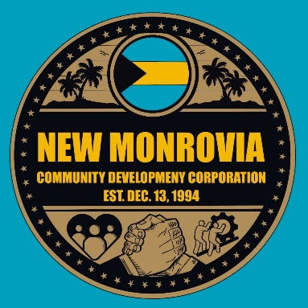
New Monrovia Community Development Corporation
P.O. Box 1165
Port Salerno, FL 34992
July 12, 2026
To Whom It May Concern:
The New Monrovia Community Development Corporation (NMCDC), established on December 13, 1994, is a nonprofit dedicated to helping our youth achieve a better quality of life and to strengthening our neighborhood through community-driven projects. Some of our most notable accomplishments include:
- Completion of two S.H.I.P. homes within the community
- Community-wide New Monrovia clean-up initiatives
- Partnership with the Martin County Board of County Commissioners and the Martin County School Board to restore the historic One-Room Schoolhouse in New Monrovia
- Establishment of REACH (Residents Empowering All Children’s Hope), an affordable afterschool and summer program for neighborhood children

One of our most anticipated events is the annual Bahamian Connection Festival. To honor the roots of many local families who migrated from the Bahamas, our board launched this heritage festival that has since become an annual tradition drawing visitors from near and far. We are now preparing for the 30th Annual Bahamian Connection Festival, to be held on Saturday, October 3, 2026. We invite you to join us as a sponsor to help make this year’s celebration a success. Your partnership will support a meaningful cause and provide valuable visibility within our community.
Sponsorship Opportunities:
Platinum Sponsor — $1500
  - Premier logo placement on all event materials
  - Recognition as a presenting sponsor
  - Featured acknowledgment during the event
  - Complimentary vendor/exhibit space
  - Social media and website recognition

Gold Sponsor — $1000
  - Prominent logo placement on event materials
  - Recognition during the event
  - Social media and website recognition
  - Complimentary vendor/exhibit space

Silver Sponsor — $750
  - Logo placement on select event materials
  - Website and social media recognition

Bronze Sponsor — $500
  - Name listed in the event program
  - Website recognition

Board Members
Gary Reed
President

Harold Jackson
Vice-President

Gailya Delancy
Treasurer

Laronda Gray
Secretary

Cotrina Washington-
Clark

Yolanda Owens-
McFarquhar

Kimberly McHardy

Chandler Josie

LeRoy Minnis, Sr.
(Emeritus)

Address:
P.O. Box 1165
Port Salerno, FL 34992

Website: newmonroviacdc.com

EIN #:
65-0551284

Community Sponsor — $250
  - Name listed on sponsor signage
  - Website recognition

The sponsorship options are as follows:
Check or money order made payable to NMCDC - P. O. Box 1165, Port Salerno, FL 34992
CashApp $NewMonroviaCDC

Your sponsorship will directly support the Bahamian Festival event costs and other activities/events that the NMCDC conducts throughout the year. We would be honored to partner with you to make this event a success.
For sponsorships or additional information, please contact Gailya Delancy at 772-834-4789 or delancy365@comcast.net. Kindly confirm your participation by September 11th, 2026.
Thank you for your consideration and for your commitment to strengthening our community. We look forward to partnering with you.
Sincerely,
Kimberly McHardy
New Monrovia CDC

